

**Topic: Using Android Studio to create a basic App.**

**Name: MD ASHIKUR RAHMAN.**

**Major: Computer Science and Technology.**

**Subject: Android Development**

**Student ID: 20170919**

**Teacher Name: Wu Yifan (吴以凡)**



**The Famous Foods in China**

**Abstract**:

Chinese food culture is a fascinating and diverse culinary tradition that has captivated people around the world. With its rich history, regional variations, and emphasis on balance and harmony, Chinese cuisine offers a unique gastronomic experience. This paper aims to explore the key aspects of Chinese food culture, including its regional diversity, staple ingredients, cooking techniques, symbolism, and dining etiquette. By understanding the nuances and significance of Chinese food culture, we can gain a deeper appreciation for its culinary traditions and the cultural values it represents.

**Introduction**

Food holds significant significance for the Chinese people. With thousands of years of history and development, China has a great range of cuisines and food, which will take you a lifetime to sample. Chinese cuisine has a long history and is well-known across the world. Chinese cuisine has evolved and grown throughout the years, resulting in a rich cultural richness. It is distinguished by quality component selection, accurate processing, special attention to the quantity of fire, and significant sustenance. Regional tastes, snacks, and unique cuisines have evolved in response to local goods, climate, historical influences, and eating patterns. The evolution and diversity of Chinese culinary pleasures are also symbolic of China's lengthy history. New recipes were developed with each dynasty until the skill of food preparation reached its pinnacle during the Qing Dynasty (1644 - 1911). Man Han Quan Xi, a supper that combines the finest of Man and Han cuisine, is highly regarded, featuring several courses, each with its own particular flavor and charm. In its preparation and presentation, this true meal represents all of the cultural and culinary skills that have been refined over generations, and it is a comprehensive fusion of taste, instruments, and manners. It also has its own taste and attraction among our ethnic groupings, which is pretty unique. Local food, imperial foods, ethnic minority dishes, Islamic dishes with a strong religious character, and vegetarian dishes are also available in China

**Unique cooking style**

Cooking techniques also play a crucial role in Chinese cuisine, and I will explore the various methods employed. These techniques not only preserve the natural flavor and textures of the ingredients but also contribute to the overall aesthetic appeal of the dishes. A typical male will have two things - a carbohydrate or starch like noodles, rice, or buns, and accompanying stir fries or dishes of veggies, fish, and meat. They use a lot of fresh vegetables like mushrooms, water chestnuts bamboo, and even tofu. In North China, wheat-based accompaniments like noodles and steamed buns dominate the table, in contrast to South China where rice is a favorite. The short-grain, stick rice grown throughout Southern China, is absolutely irresistible.

**Here I am going to explore 5 favorite food in China.  
Hotpot:**

Hotpot, also known as huǒguō, is a beloved Chinese culinary tradition that brings people together for a communal and interactive dining experience. Originating in the Sichuan region, hotpot involves a simmering pot of flavorful broth placed at the center of the table, surrounded by a variety of raw ingredients like thinly sliced meats, fresh vegetables, mushrooms, tofu, and dumplings. Diners cook these ingredients in the bubbling broth, customizing their flavors and spice levels with dipping sauces. The hotpot experience highlights the importance of shared meals and the joy of gathering around a steaming pot to enjoy a hot, flavorful feast.

**Beijing Duck:**

Beijing duck, or Peking duck as it is commonly known, is a world-renowned dish that originated in the capital city of China. This iconic delicacy features tender, succulent duck with crispy, golden-brown skin. The preparation of Beijing duck involves meticulous steps, including air-drying the duck, glazing it with a sweet and savory marinade, and then roasting it in a special oven. The result is a dish that combines contrasting textures and flavors, with the crispy skin served alongside thin pancakes, scallions, cucumber, and hoisin sauce. The art of carving and serving Beijing duck is a spectacle in itself, showcasing the precision and elegance that characterizes Chinese culinary traditions.

**Noodles:**

Noodles have long been a staple in Chinese cuisine, with a myriad of regional variations and styles. From the hearty and spicy dan dan noodles of Sichuan to the delicate and soupy Guilin rice noodles, there is a noodle dish to suit every palate. Chinese noodles can be made from wheat, rice, or mung bean starch, and they are cooked using various techniques such as boiling, stir-frying, or braising. Noodles are often served in flavorful broths or tossed with a variety of sauces and toppings, making them a satisfying and versatile choice for any meal.

**Kung Pao Chicken:**

Kung Pao chicken, also known as Gong Bao chicken, is a classic Sichuan dish renowned for its bold and spicy flavors. This stir-fried dish typically features tender chunks of chicken cooked with peanuts, dried chili peppers, Sichuan peppercorns, and a savory sauce. The combination of heat, numbing sensation from the Sichuan peppercorns, and the crunchy texture of peanuts creates a harmonious blend of flavors and textures. Kung Pao chicken exemplifies the characteristic balance of sweet, spicy, salty, and sour flavors that are central to Sichuan cuisine.

**Baozi:**

Baozi, often referred to as steamed buns, are a popular street food and breakfast item in China. These soft and fluffy buns are filled with various savory or sweet fillings, such as minced pork, vegetables, or red bean paste. Baozi can be steamed or pan-fried, resulting in a delightful combination of textures. These comforting treats are not only a delicious on-the-go snack but also an integral part of Chinese food culture, representing the importance of steamed bread and dumplings in daily meals.

**Introduction of Android Studio**

Android Studio is an integrated development environment (IDE) specifically designed for developing Android applications. It provides developers with a powerful and feature-rich platform to design, build, test, and deploy Android apps. This report aims to provide an overview of Android Studio, highlighting its key features and benefits.

**Integrated Development Environment (IDE)**

Android Studio offers a complete and user-friendly IDE that streamlines the app development process. It includes a code editor with advanced features such as code completion, refactoring, and debugging tools. The layout editor simplifies the design process, allowing developers to create intuitive user interfaces easily.

**Gradle Build System**

Android Studio employs the Gradle build system, which automates tasks such as compiling code, managing dependencies, and creating APK files. Gradle offers flexibility and scalability, enabling developers to customize build configurations and easily incorporate third-party libraries into their projects.

**Android Virtual Device (AVD) Manager**

The AVD Manager allows developers to create and manage virtual devices for testing their applications. It provides a variety of device configurations, screen sizes, and Android versions, enabling comprehensive testing across different device profiles.

**Android Emulator**

Android Studio includes a powerful emulator that allows developers to test their apps on virtual devices without the need for physical hardware. The emulator supports various hardware features, including GPS, camera, and multi-touch input, providing a realistic testing environment.

**Profiling and Debugging Tools**

Android Studio offers robust profiling and debugging tools to help developers identify and resolve performance issues. It provides real-time CPU, memory, and network usage monitoring, allowing developers to optimize their apps for better performance and efficiency.

**Android Studio Step by Step**

* Android Studio offers even more features that enhance our productivity when building Android apps, such as:
* A flexible Gradle-based build system
* A fast and feature-rich emulator
* A unified environment where you can develop for all Android devices
* Apply Changes to push code and resource changes to your running app without restarting your app
* Code templates and GitHub integration to help you build common app features and import sample code
* Extensive testing tools and frameworks
* Lint tools to catch performance, usability, version compatibility, and other problems
* NDK support
* Built-in support for [Google Cloud Platform](https://cloud.google.com/tools/android-studio/docs/), making it easy to integrate Google Cloud Messaging and App Engine

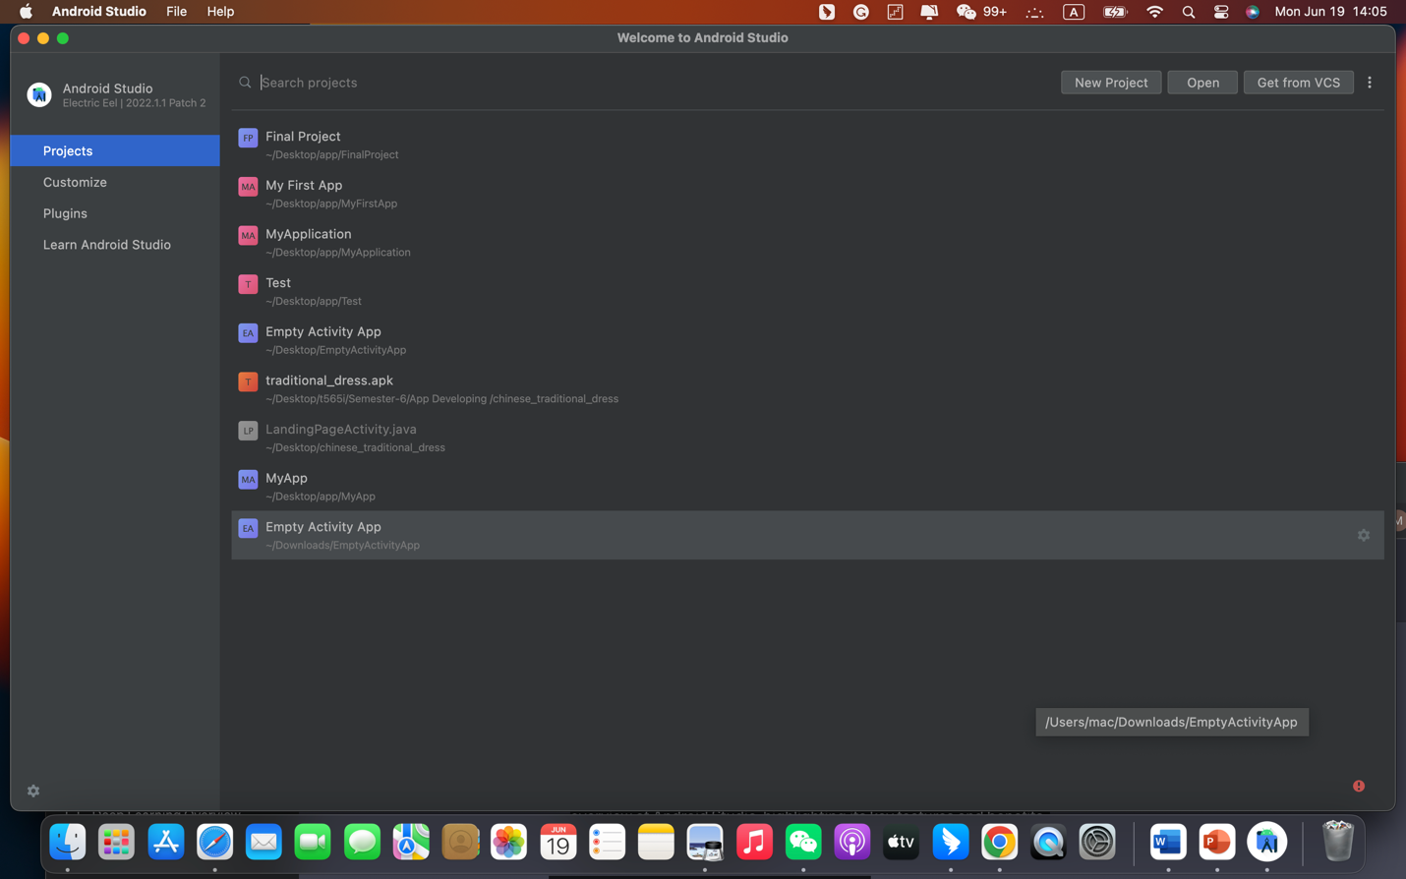

**Create a first Android project on our laptop Step by Step  
To create a new Android project, we have to follow Step by Step:**

* Install the latest version of [Android Studio](https://developer.android.com/studio/).
* In the Welcome to Android Studio window, click Create New Project.
* If you have a project already opened, select File > New > New Project.
* In the Select a Project Template window, select Empty Activity and click Next.

In the Configure your project window, complete the following:

* 1. Enter "Any name" in the Name field.
  2. Enter "com. example. my first app" in the Package name field.
  3. If you'd like to place the project in a different folder, change its Save location.
  4. Select either Java or Kotlin from the Language drop-down menu.

1. Select the lowest version of Android you want your app to support in the Minimum SDK field.
   1. If your app will require legacy library support, mark the Use legacy android.support libraries checkbox.
   2. Leave the other options as they are.
2. Click Finish.

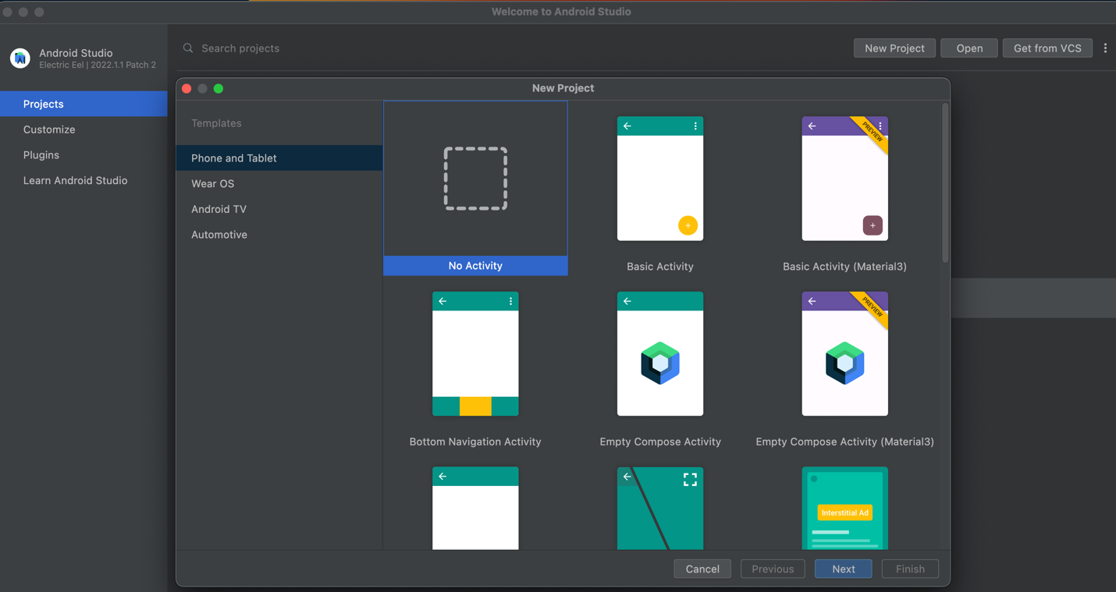

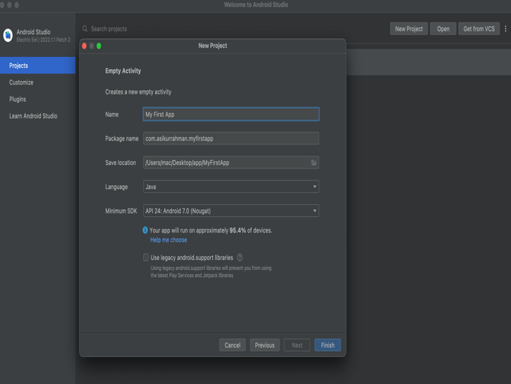 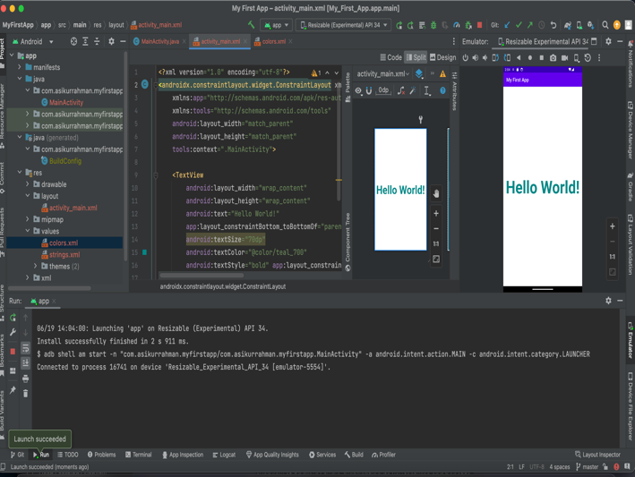

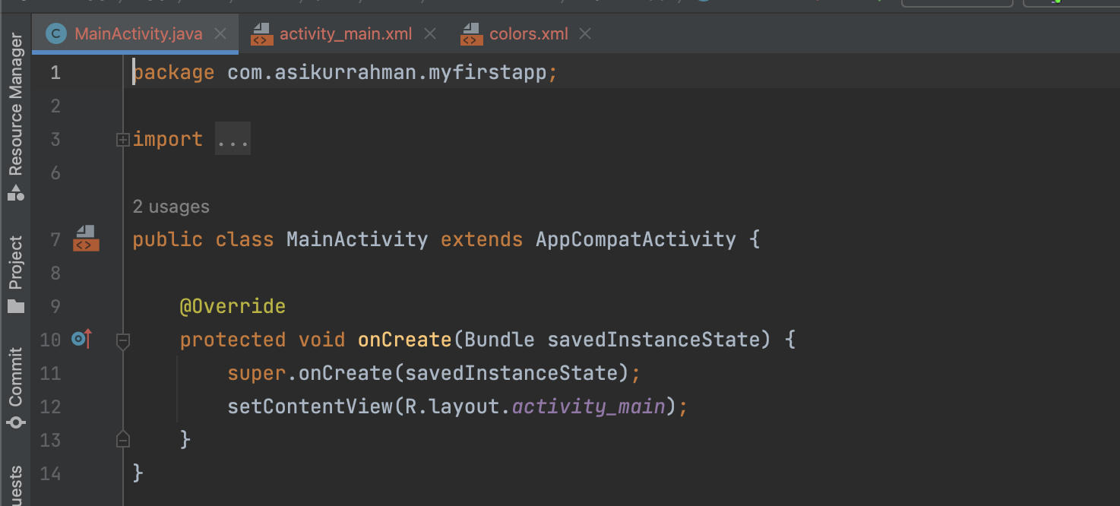

**UI:**The teacher required that our app should start with a Landing page That why On My APP UI **start with the Landing page**.

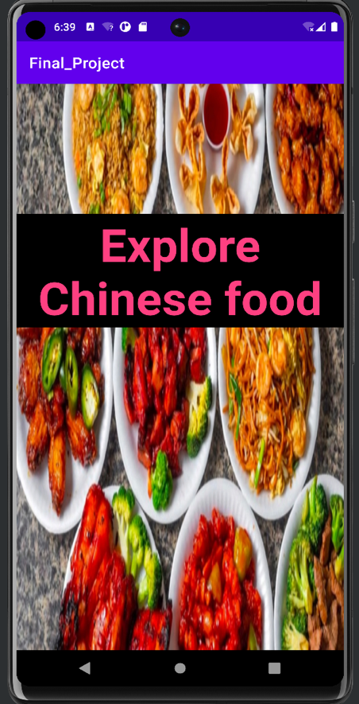 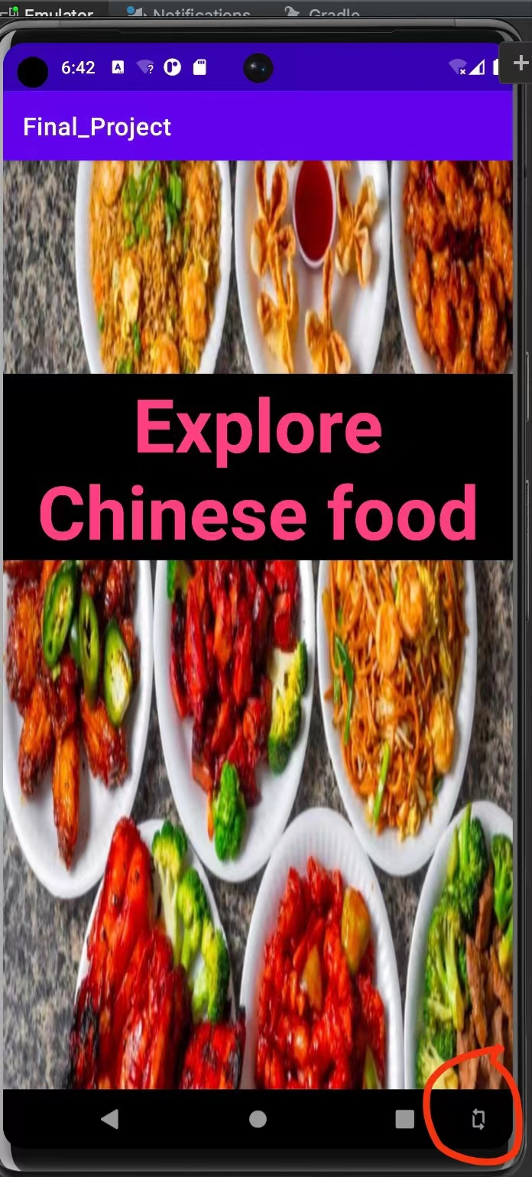

This Picture show My first landing page for my app and when we will click the button of inside red circle it will be change as a landscape.

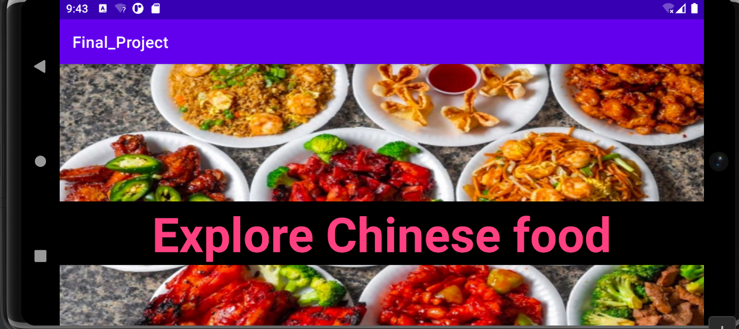

**Layout:**

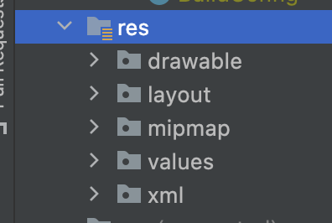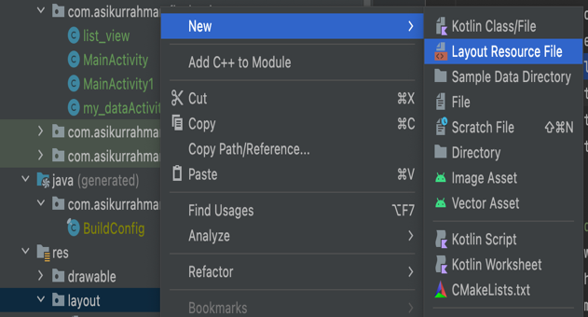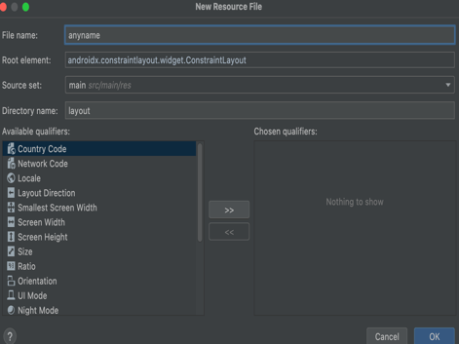

For creating UI Frist step will be make a new layout for that, We have to go to resource file(res) dabble click on res file and go down to layout right click and go to new and Layout Resource File give name of the layout then add it.

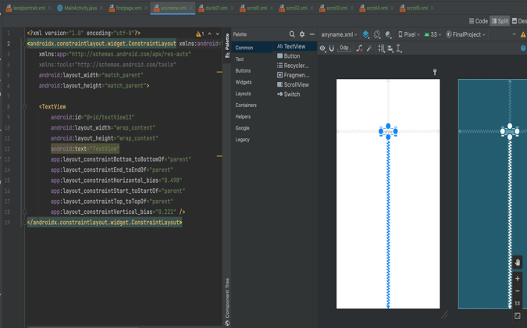 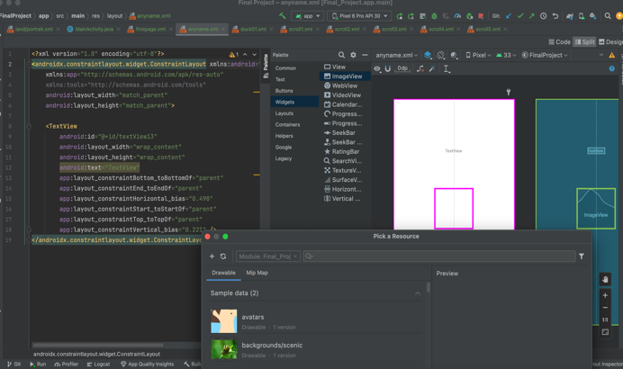

Drag and drop text view edit text view as you want and drag and drop image view select Image from @drawable and select image name An Example app:srcCompat="@drawable/baozi1".

Another way is we can direct writing code and create and make add text view and button or other features as well.

For my first UI for my food I add layout name as a firstpage and for my first UI food is Hot pot. For hot pot I created 5 deferent UI layout and design it deferent way and for every page deferent content tried add more information for each page.

 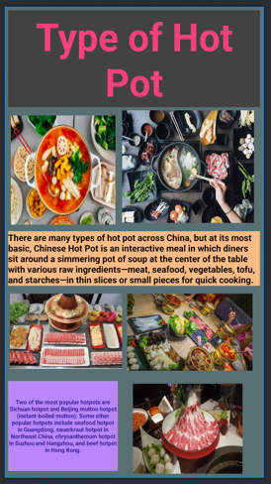 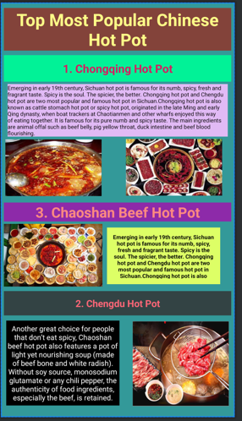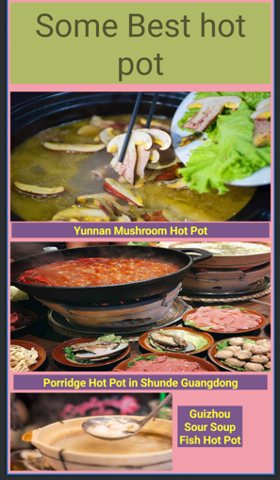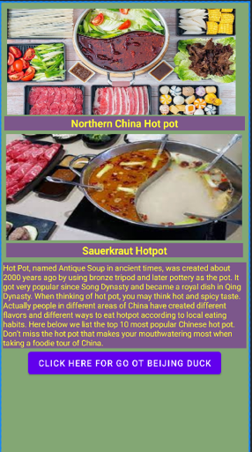

**Second one is Peking duck also 5 UI layout**:For peking duck second layout I add background Image.for fourth UI I add resipe

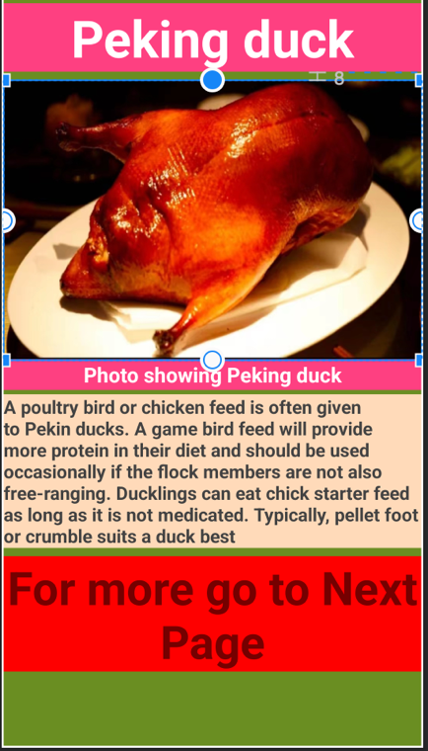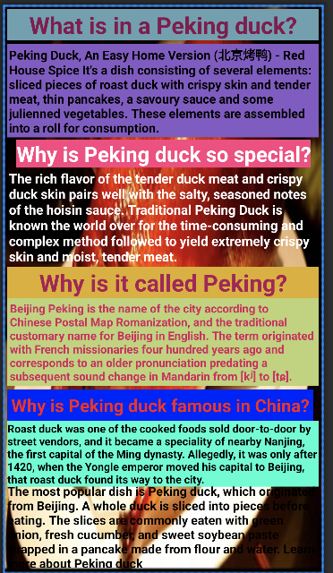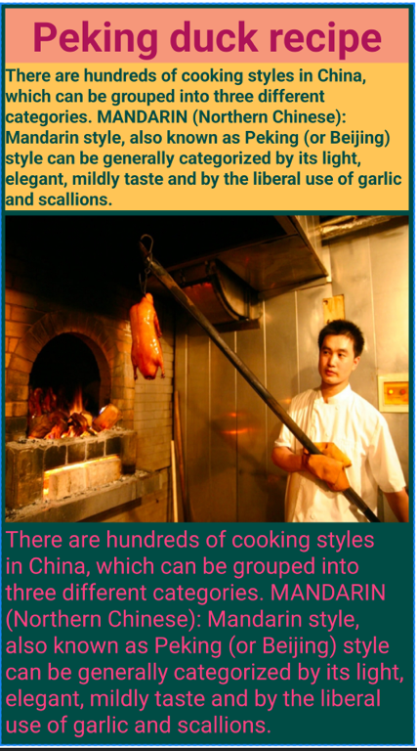

**Third one is noodles:** For noodeles I also **add 5 UI layout** for noodles

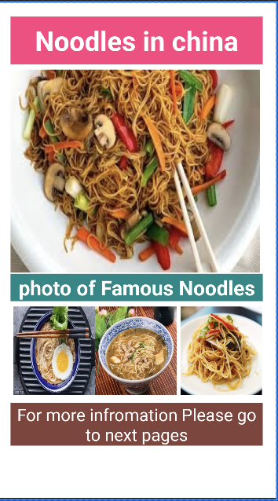 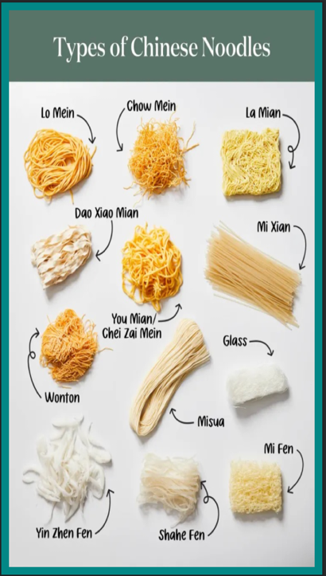 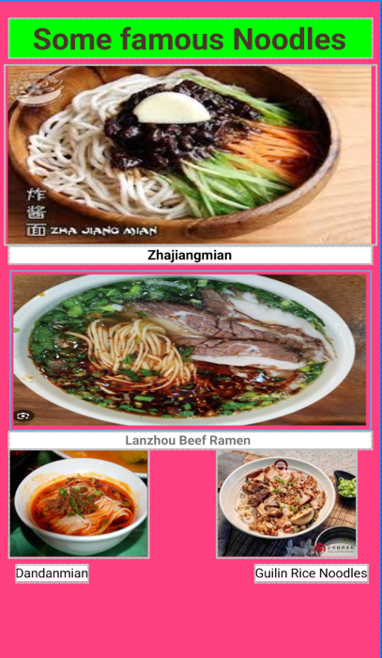

**Number 4 is Kung pao chicken:** For kung pao chicken I make 3 layout I

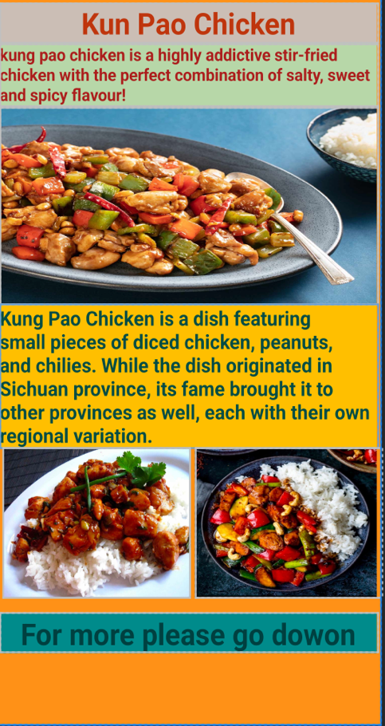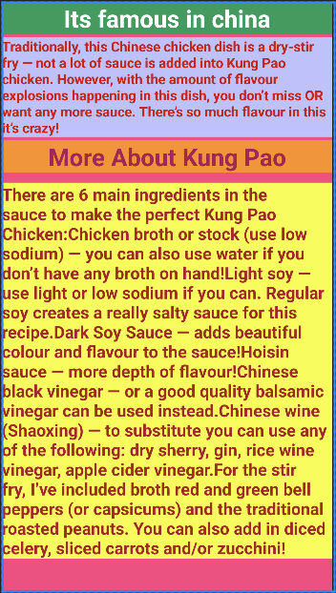 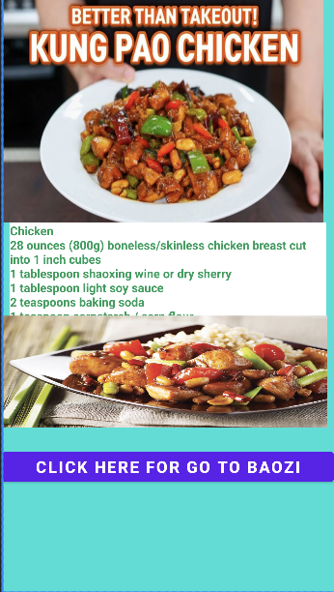

**And my last UI is about Baozi:** For my last food I add 2 layout

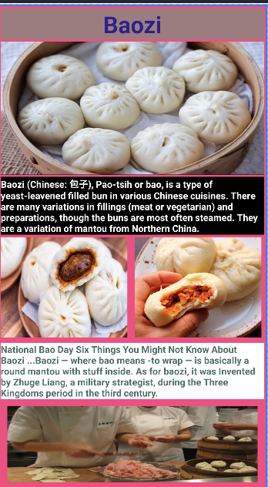 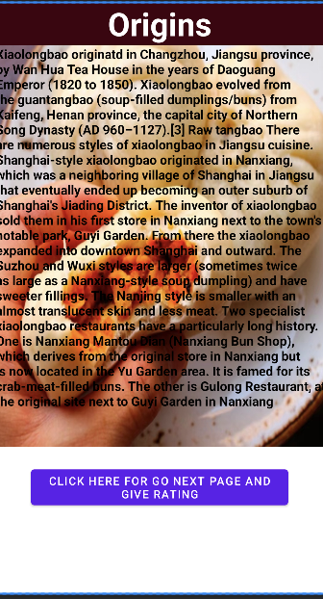

**Drawable:**

In Android, a "drawable" is a resource type used to define visual assets such as images, icons, and graphics for the user interface of an application. It includes bitmap drawables (static images), vector drawables (resolution-independent graphics), shape drawables (simple shapes defined in XML), nine-patch drawables (resizable images), and layer list drawables (combining multiple drawables). Drawables are stored in the res/drawable directory and can be referenced in XML layout files or programmatically in code. They help enhance the visual appeal of Android applications.

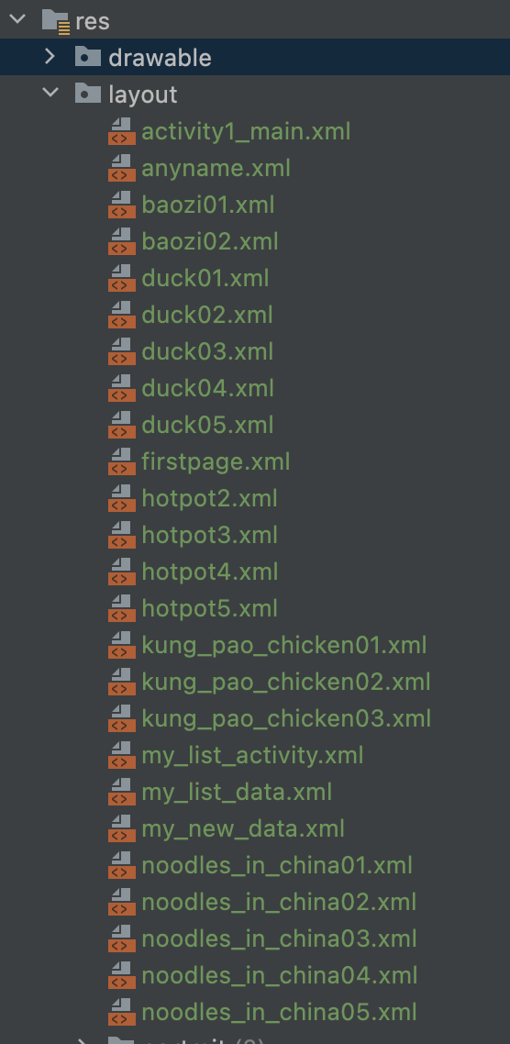

**List view:**

The picture below shows the list view of my Application which is created as a listview java file. The list view shows five different items of Chinese food that I have created in five different layout.xml files on my resource. Each food item has been created in a constraint layout using text view and image view.

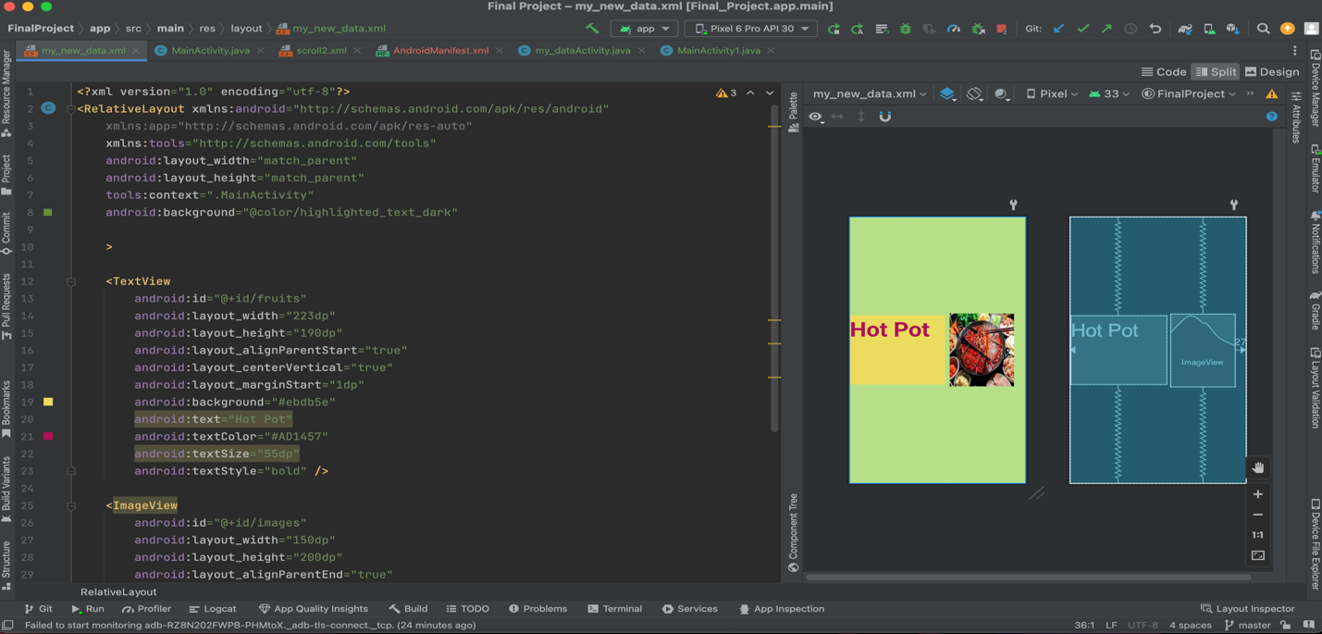

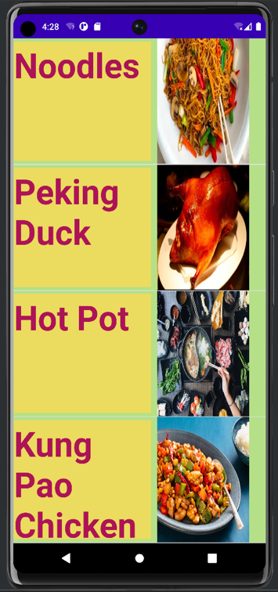 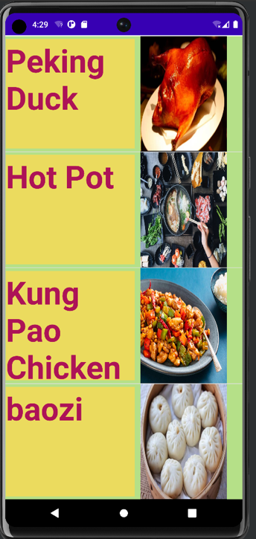

**Implementation:**

Following the picture Shows the Main implementation of my app

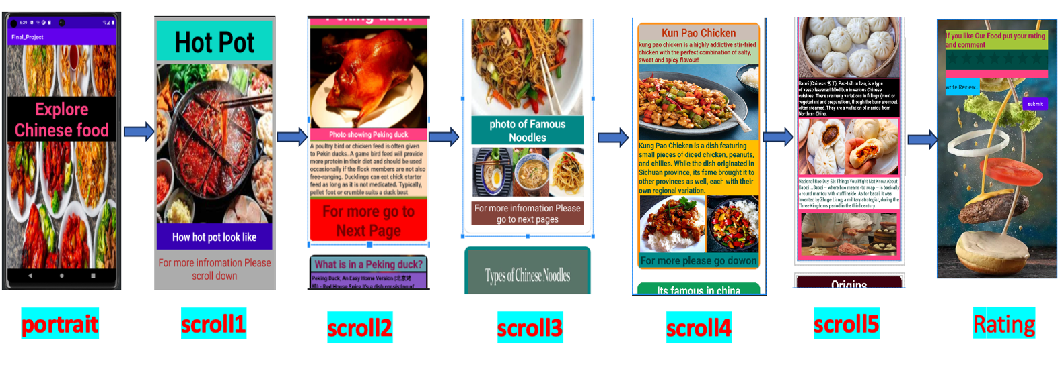

In my app the first page Start with a portrait from the first page if want to go to the next page just have to click anywhere on the screen then will start to scroll View for go to Next Page I Add button on the last page on every scroll view if we click the button it will go the next page.

**How I connected each page to others:**

<Button

android:id="@+id/button2"

android:layout_width="wrap_content"

android:layout_height="wrap_content"

android:onClick="first_food_list"

android:text="@string/hot_pot16"

app:layout_constraintBottom_toBottomOf="parent"

app:layout_constraintEnd_toEndOf="parent"

app:layout_constraintHorizontal_bias="0.498"

app:layout_constraintStart_toStartOf="parent"

app:layout_constraintTop_toBottomOf="@+id/textView63"

app:layout_constraintVertical_bias="0.0" />

In above code it can be seen android:onClick= “……”. This particular line of code set the onClick option on the button. like wise, we create the function in MainActivity which will redirect us to the page we want to visit. The code is given below

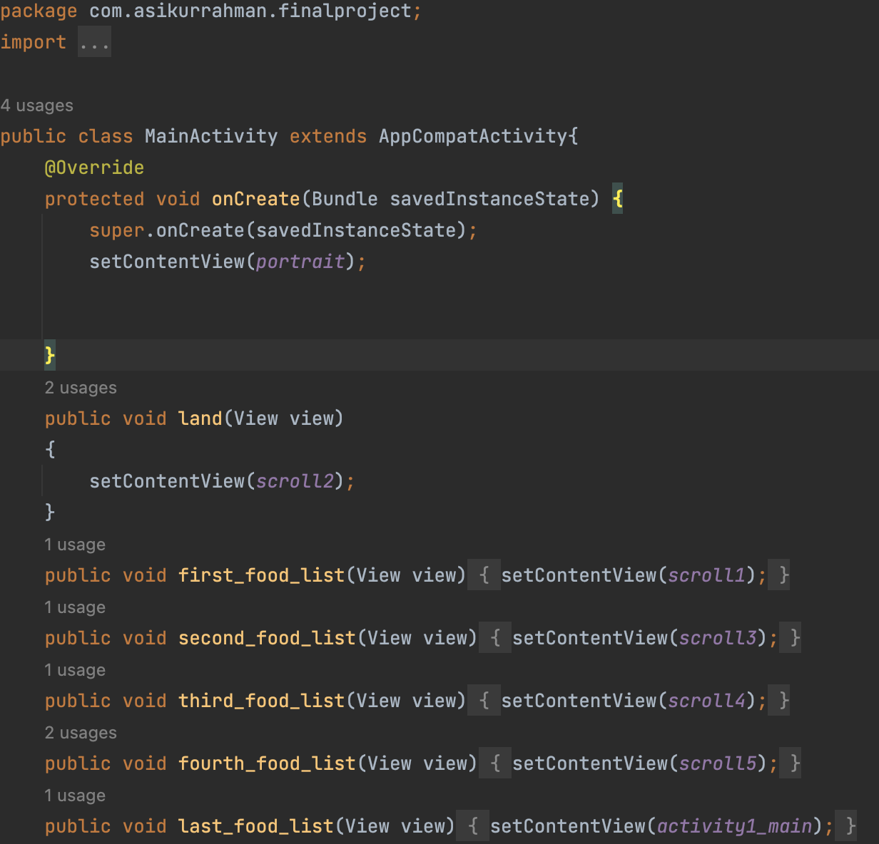

**public void land(View view)**

**{**

**setContentView(scroll2);**

**}**

**Code :1**

This is the main code in our main java activity the android:onclick=”name” is what trigger the layout after pressing the button the onclick has assigned with a specific name like for this code I took a sample name i.e. =name . now we create a function as shown in the code above a void function with the same name that is set on onClick in button. After the function has been created the argument passed into the function is View which is how we view the next page. The setcontenview(R.layout.scroll1) takes us to the layout where we desire to go.

We do this every page when want to go. For example if we want to go from page 1 to page 3. First of all, we need to add android:onclick=”----” on the page one. We assign this code to the button since button ius easy and clickbale and our app looks more authentic. After the onclick has been set on button now we write a function as shown in code 1 into our mainactivity. will direct us to page 3

Moving on to scrollview. Adding a scrollview can be really challenging as it need to create a scroll view.

<?xml version="1.0" encoding="utf-8"?>  
<ScrollView xmlns:android="http://schemas.android.com/apk/res/android"  
 android:layout_width="match_parent"  
 android:layout_height="match_parent"  
 xmlns:app="http://schemas.android.com/apk/res-auto">  
 <LinearLayout  
 android:layout_width="match_parent"  
 android:layout_height="wrap_content"  
 android:orientation="vertical">  
  
 <androidx.cardview.widget.CardView  
 android:layout_width="match_parent"  
 android:layout_height="match_parent"  
 android:layout_gravity="center"  
 android:layout_margin="@dimen/card_margin"  
 app:cardCornerRadius="@dimen/card_corner_radius"  
 app:cardElevation="2dp"  
 app:cardUseCompatPadding="true">  
 <include layout="@layout/duck01"/>  
 </androidx.cardview.widget.CardView>  
 <androidx.cardview.widget.CardView  
 android:layout_width="match_parent"  
 android:layout_height="match_parent"  
 android:layout_gravity="center"  
 android:layout_margin="@dimen/card_margin"  
 app:cardCornerRadius="@dimen/card_corner_radius"  
 app:cardElevation="2dp"  
 app:cardUseCompatPadding="true">  
 <include layout="@layout/duck02"/>  
 </androidx.cardview.widget.CardView>  
 <androidx.cardview.widget.CardView  
 android:layout_width="match_parent"  
 android:layout_height="match_parent"  
 android:layout_gravity="center"  
 android:layout_margin="@dimen/card_margin"  
 app:cardCornerRadius="@dimen/card_corner_radius"  
 app:cardElevation="2dp"  
 app:cardUseCompatPadding="true">  
 <include layout="@layout/duck03"/>  
 </androidx.cardview.widget.CardView>  
 <androidx.cardview.widget.CardView  
 android:layout_width="match_parent"  
 android:layout_height="match_parent"  
 android:layout_gravity="center"  
 android:layout_margin="@dimen/card_margin"  
 app:cardCornerRadius="@dimen/card_corner_radius"  
 app:cardElevation="2dp"  
 app:cardUseCompatPadding="true">  
 <include layout="@layout/duck04"/>  
 </androidx.cardview.widget.CardView>  
 <androidx.cardview.widget.CardView  
 android:layout_width="match_parent"  
 android:layout_height="match_parent"  
 android:layout_gravity="center"  
 android:layout_margin="@dimen/card_margin"  
 app:cardCornerRadius="@dimen/card_corner_radius"  
 app:cardElevation="2dp"  
 app:cardUseCompatPadding="true">  
 <include layout="@layout/duck05"/>  
 </androidx.cardview.widget.CardView>  
 </LinearLayout>  
</ScrollView>

In the code, we can see that the different layouts are bound together using **<include layout="@layout/duck01"/>**

This specific line of code binds the layout together. For example, for the hot pot I have represented five layouts so I will need to bind 5 different layouts using the same code.

Reminder: while making a scroll view we should make sure to make a new layout file but use the scroll view option, not relative layout or constraint layout. Also, every layout for items is bound in card view which we can observe for the code above.

**App logo:** This is the picture that I use as an app icon.

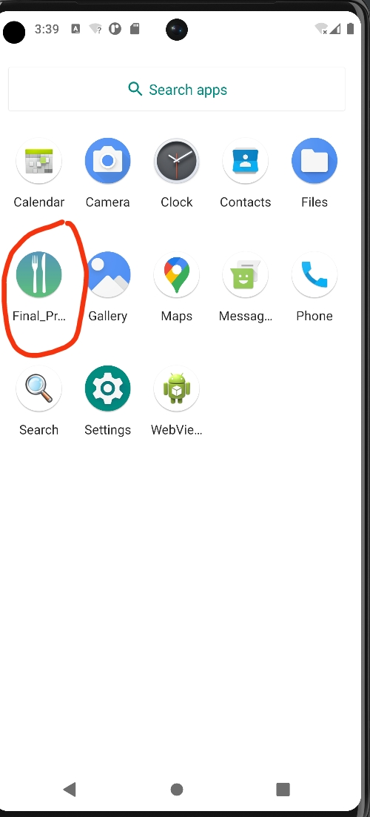 

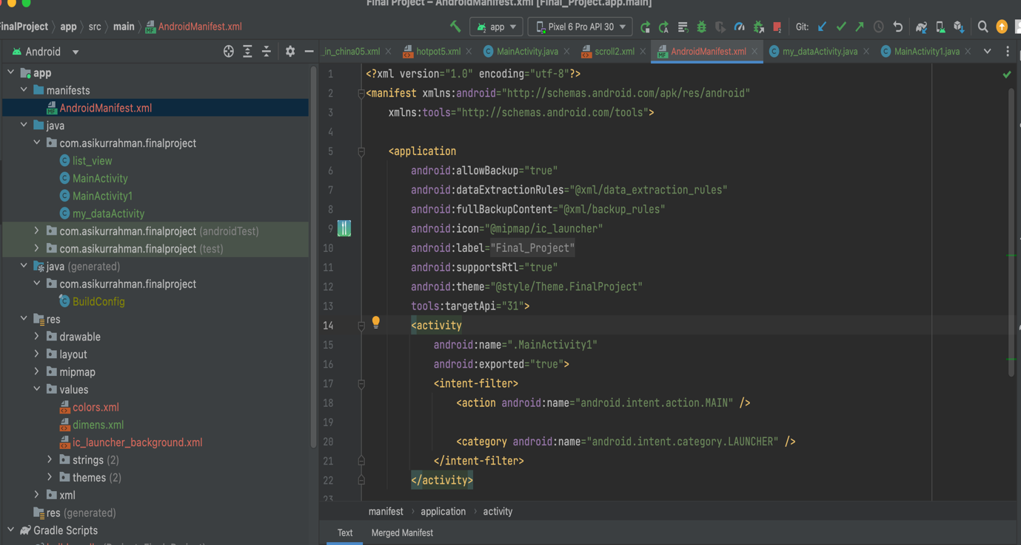

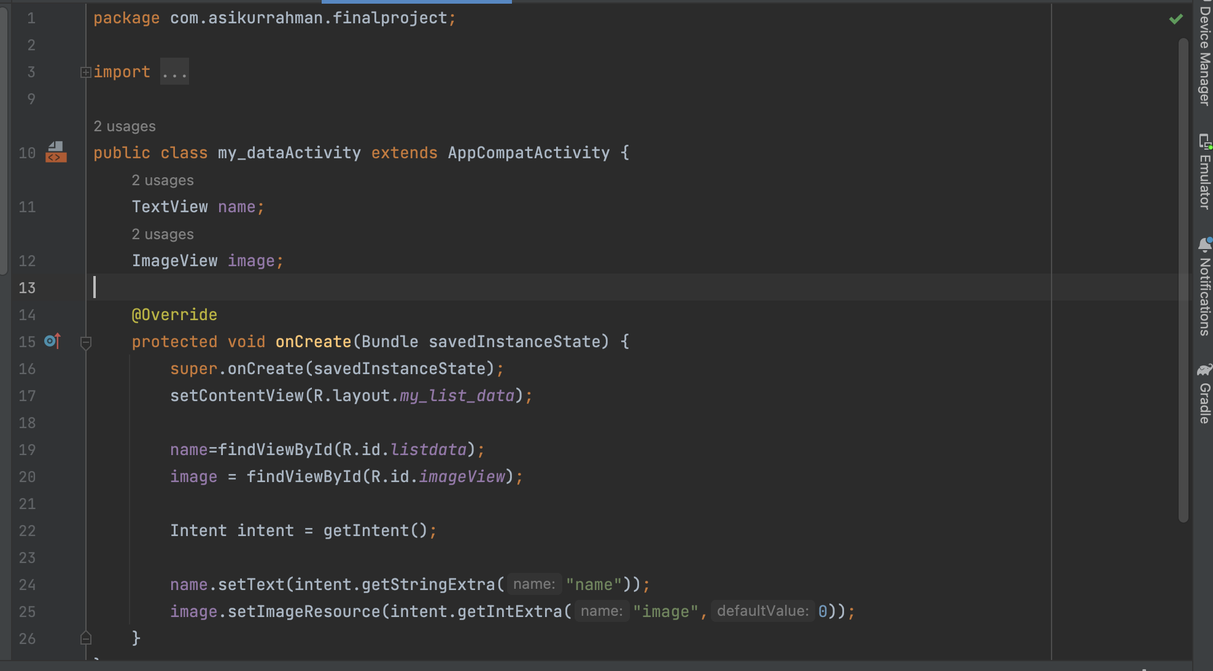

**Rating review:**

This is the app's last activity called the MainActivity1 which shows the rating layout activity1_main. When the user clicks on the rating button it will show the good rating and bad rating writing their users review it when the User clicks submit button it will submit on the server. Here key is the position of the item in the list. When the user clicks on it later the rating can change.

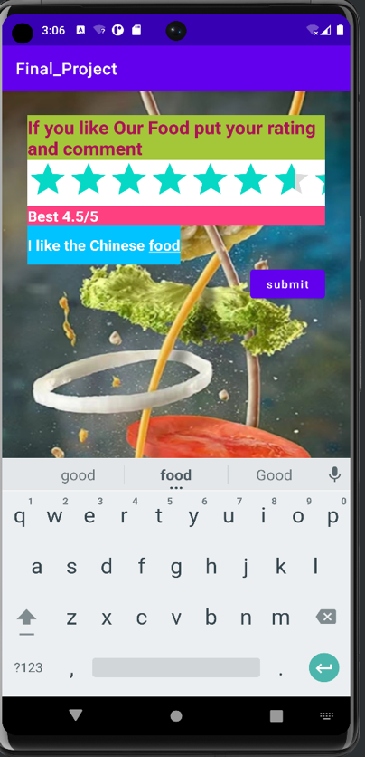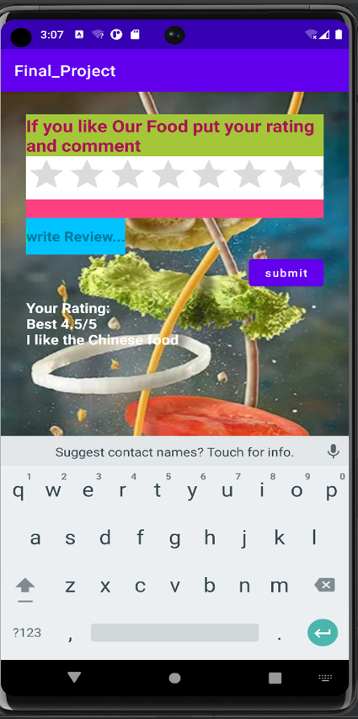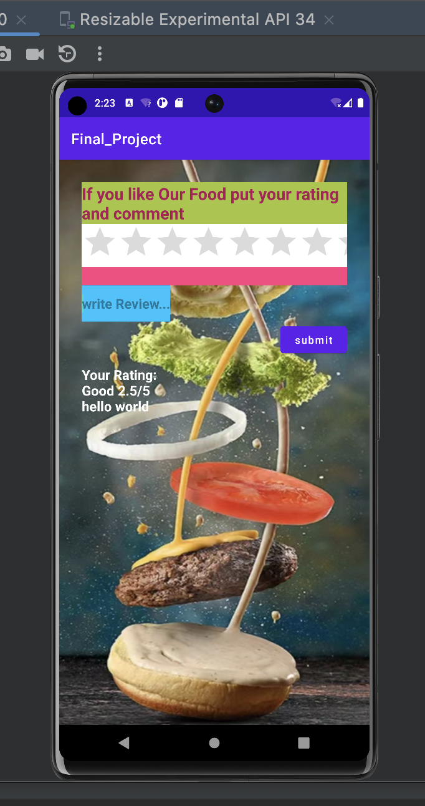

**@Override**

**public void onRatingChanged(RatingBar ratingBar, float v, boolean {**

**rateValue = ratingBar.getRating();**

**if (rateValue <= 1 && rateValue > 0)**

**rateCount.setText("Bad " + rateValue + "/5");**

**else if (rateValue <= 2 && rateValue > 1)**

**rateCount.setText("OK " + rateValue + "/5");**

**else if (rateValue <= 3 && rateValue > 2)**

**rateCount.setText("Good " + rateValue + "/5");**

**else if (rateValue < 4 && rateValue > 3)**

**rateCount.setText("Very Good " + rateValue + "/5");**

**else if (rateValue < 5 && rateValue > 4)**

**rateCount.setText("Best " + rateValue + "/5");**

**}**

**});**

**MainActivity1 is for my rating and review.**

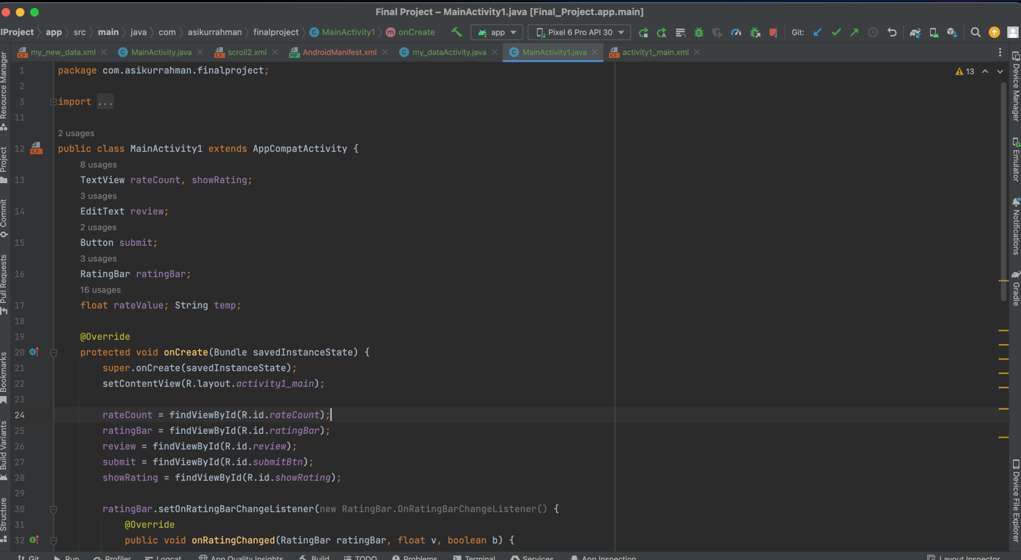

**String:**

For every single text and button name I use a string because we have to add translate for the name and for strings, I especially add two strings because we have to translate our all text files into Chinese and English.

**<resources>**

**<string name="….."> Text </string>  
</resources>**

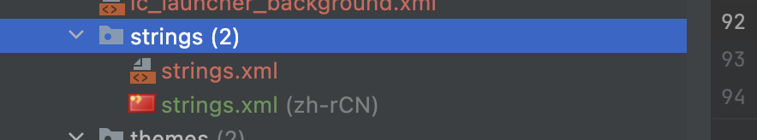

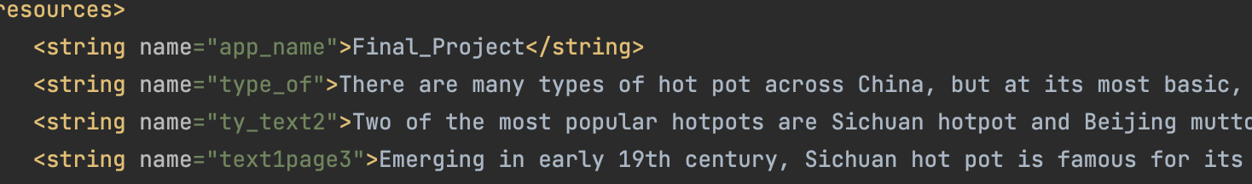

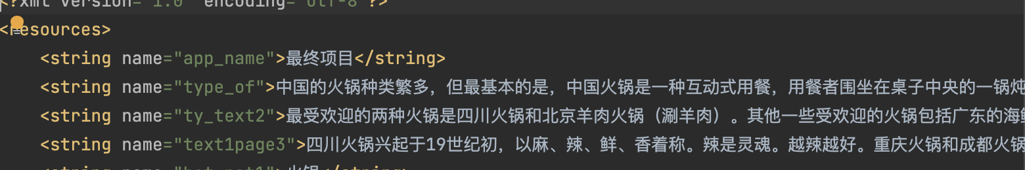

**Translate:**

I made two string resource files same content and different languages one is Chinese another is English If we want to add more languages we just have to choose the language and add one more string and just use some translator translate then copy and paste inside the string.

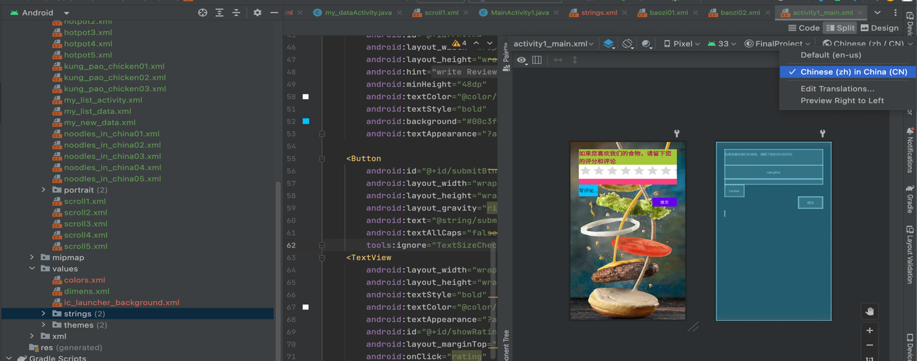

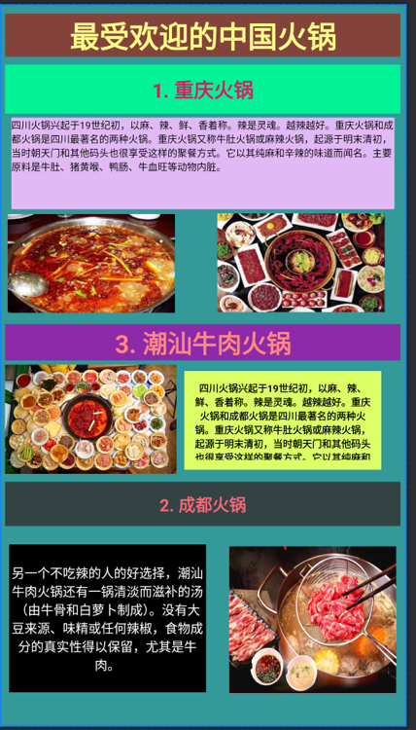 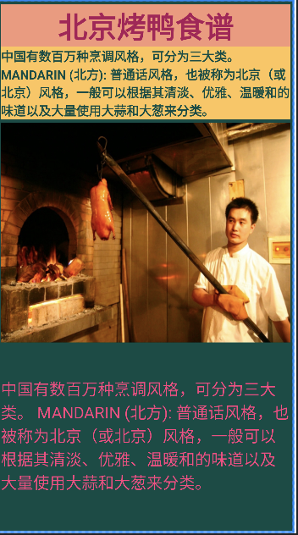 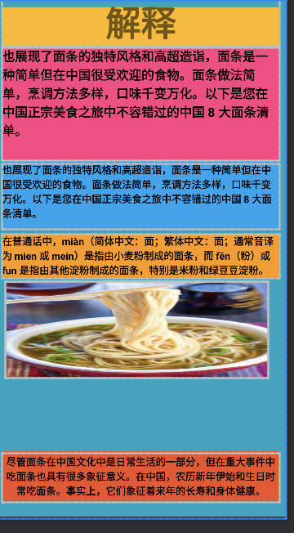

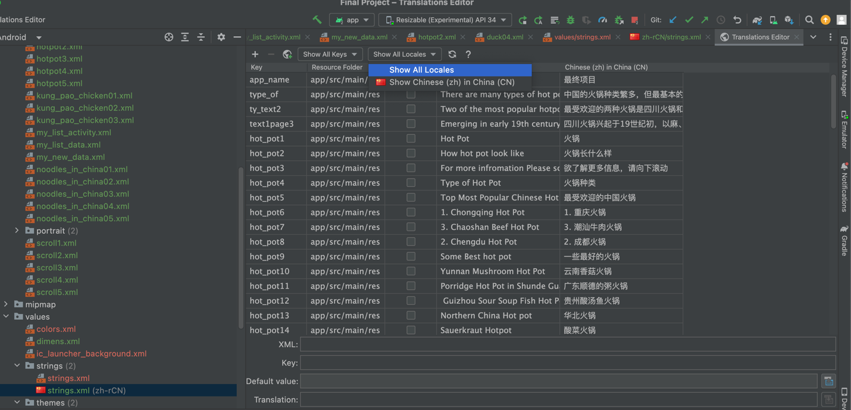

**Color:**

We can edit our text color background even our text background for making our UI unique and beautiful or colorful for that we can directly add the hex color an example #000000 for black another way to add color code to the color.xml file and use **“@color/name”**

<resources>

<color name="purple_200">#FFBB86FC</color>

<resources>

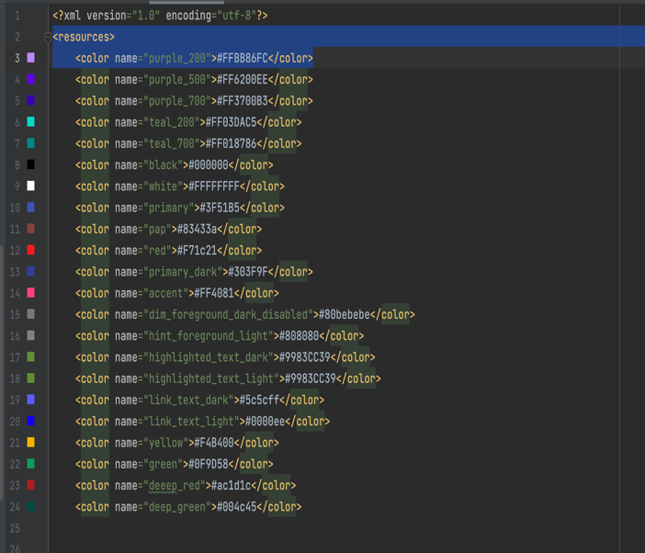 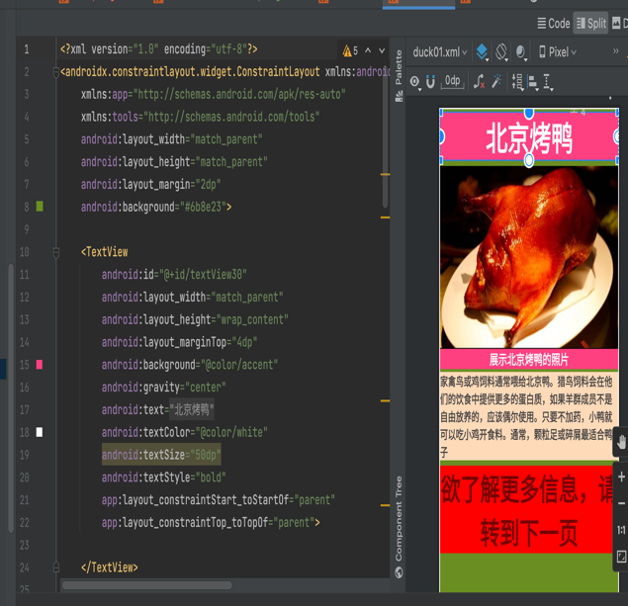

**Conclusion:**

In conclusion, Android Studio offers invaluable support and resources for students venturing into Android app development. Its user-friendly interface, powerful code editor, design tools, and testing capabilities provide a robust platform for learning and creating Android applications. By using Android Studio, students can gain hands-on experience in coding, debugging, and designing user interfaces, helping them build practical skills that are in high demand in the tech industry. Furthermore, Android Studio's integration with Gradle, documentation, and community support fosters a collaborative learning environment and encourages students to explore and overcome challenges. Learning Android app development not only equips students with a sought-after skillset but also empowers them to bring their innovative ideas to life in the fast-paced world of mobile applications.

Overall, creating an app on Android Studio is a dynamic and fulfilling experience. It provides a user-friendly interface, efficient code editing, and testing capabilities. With Android Studio, you can transform your ideas into functional Android applications, utilizing a wide range of tools and resources. It empowers developers to bring their creative visions to life, making app development accessible and exciting.